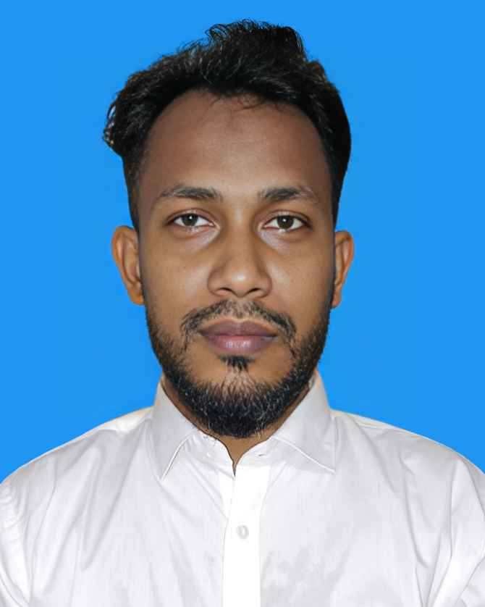

## Software Engineer | Full Stack Developer

Phone: +8801822969122

WhatsApp: +8801822969122

Email: [enamulhoque007m@gmail.com](mailto:enamulhoque007m@gmail.com)

RESUME OF

# ENAMUL HOQUE

LinkedIn: <https://www.linkedin.com/in/enamul-hoque-1a517a141> GitHub: <https://github.com/enamul007>

Address: 1768, South Manda, Dhaka-1238

# CAREER OBJECTIVE

A passionate and solutions-driven Software Engineer with proven experience in developing full-stack web applications using modern technologies. Adept at designing clean, scalable, and maintainable systems with a strong focus on performance, security, and user experience. I am seeking an opportunity in a forward-thinking organization where I can contribute to impactful projects, collaborate with innovative teams, and continuously grow through challenging real-world problem-solving.

# CAREER SUMMARY

Accomplished Full Stack Developer with a proven history of delivering enterprise-grade applications across diverse sectors such as ERP, ISP management, and e-commerce. Experienced in modern frameworks and programming languages including JavaScript, TypeScript, C#, ASP.Net Core, and SQL Server. Strong background in Agile methodologies, team collaboration, mentoring junior developers, and developing secure, high-performing software solutions.

# KEY SKILLS AND EXPERTISE:

* **Full Stack Web Development (React, ASP.NET Core)** – Capable of designing and developing both client- side and server-side components of scalable web applications.
* **Object-Oriented Programming (OOP)** – Strong foundation in OOP principles to build maintainable and reusable code structures.
* **RESTful API Design & Integration** – Skilled in creating, documenting, and consuming robust and secure APIs.
* **Database Management & Optimization** – Proficient in SQL Server & PostgreSQL with experience in schema design, complex queries, indexing, and performance tuning.
* **Modern Front-End Technologies** – Expertise in HTML5, CSS3, JavaScript, TypeScript, Tailwind CSS, Ant Design for building responsive and user-friendly UIs.
* **Version Control & DevOps Tools** – Proficient in Git, GitHub, GitLab, and basic CI/CD pipeline setup for automated deployment and code quality checks.
* **Authentication & Authorization** – Experience with JWT, OAuth, and Role-Based Access Control (RBAC) implementations.
* **Agile/Scrum Methodologies** – Comfortable working in Agile environments using tools like Jira, Trello, and participating in daily stand-ups, sprint planning, and retrospectives.
* **Software Testing & Quality Assurance** – Knowledge of unit testing (xUnit, NUnit), integration testing, and debugging techniques to ensure high-quality software.
* **System Design & Architecture** – Familiarity with microservices, MVC, clean architecture, and layered application design patterns.
* **Cloud Services & Hosting** – Basic experience with cloud platforms like Azure or AWS (EC2, S3, Lambda) and deploying web apps.
* **Containerization & Virtualization** – Understanding of Docker concepts for development and deployment consistency.
* **Performance Optimization** – Skilled in identifying performance bottlenecks in code and database, improving load times and system responsiveness.
* **Leadership & Mentoring** – Ability to guide junior developers, conduct code reviews, and share best practices to improve team productivity.
* **Continuous Learning & Technology Adaptability** – Passionate about learning emerging tools, frameworks, and staying updated with industry trends.

# PROFESSIONAL EXPERIENCE:

## Full Stack Software Engineer

**Hameem Group** (September 2024 – Present) Responsibilities:

* + Developed responsive and dynamic web applications using React 18, Tailwind CSS, and Ant Design
  + Designed RESTful APIs using ASP.Net Core 8
  + Integrated secure authentication and user access systems
  + Participated in sprint planning, daily stand-ups, and Agile workflows
  + Conducted code reviews and mentored junior team members

## Software Engineer

**Royal Green Limited** (September 2020 – September 2024) Responsibilities:

* + Developed ERP modules including Business, Inventory, Sales, Purchase, HRM, and Ticketing
  + Built cloud-based portals for virtual machine (VM) management
  + Implemented key system integrations for ISP service management
  + Worked directly with clients to define and deliver project requirements

## Software Engineer

**ESOL** (August 2018 – September 2020) Responsibilities:

* + Developed Security Services ERP modules (Inventory, Sales, Purchase) using ASP.NET MVC 5
  + Worked on sobkichu.com e-commerce admin panel, APIs, and payment gateway integration
  + Contributed to an employee tracking system for real-time location monitoring
  + Optimized database queries and performance for MSSQL 2014

## Junior Software Engineer

**Opus Technology** (August 2017 – August 2018) Responsibilities:

* + Contributed to CRM and Sales modules of Credit Rating ERP
  + Built UI components using jQuery, Bootstrap 3.7, and ASP.NET MVC5
  + Developed and maintained stored procedures and SQL queries

# EDUCATIONAL QUALIFICATIONS:

* **MSc in Chemistry** – Dhaka College, 2012, Second Class (58%)
* **MSc in ICT** – Dhaka College, 2012, A+ 4.00(out of 4)

 **BSc in Chemistry** – Dhaka College, 2011, Second Class (52%)

 **HSC (Science)** – MA Hasem University College, 2006, GPA 4.30 (out of 5)

 **SSC (Science)** – AKP High School, 2004, GPA 4.56 (out of 5)

# SPECIAL TRAINING SUMMARY:

## Web Development (Dot Net Development)

**Institute:** BITM, Bangladesh | **Location:** Kawran Bazar, Dhaka | **Year:** 2017 | **Duration:** 3 months

## Enterprise Systems Analysis & Design - C#.NET

**Institute:** IDB-BISEW | **Location:** Dhaka, Bangladesh | **Year:** 2016 | **Duration:** 15 months

## ICT (Information Communication Technology)

**Institute:** Dhaka College | **Location:** Dhaka, Bangladesh | **Year:** 2015 | **Duration:** 1 year

# HOBBIES AND INTERESTS:

* + Web development and coding challenges
  + Reading tech blogs and exploring new tools
  + Contributing to open-source projects
  + Traveling, hiking, and photography

# EXTRA-CURRICULAR ACTIVITIES:

* + **Sports Participation** – Actively participated in football and volleyball tournaments at the school and college level, representing the institution in various local competitions. Demonstrated strong teamwork, leadership, and discipline on the field.
  + **Cultural Engagement** – Engaged in debates, drama, and singing at the college and university level. Developed strong public speaking, communication, and creative skills through active involvement in cultural activities.
  + **Community Service** – Volunteered in various community service initiatives organized by local NGOs, including blood donation drives and distributing food to the underprivileged. Contributed to the betterment of society and honed a sense of empathy and responsibility.
  + **Event Coordination** – Assisted in organizing annual college events, including workshops, seminars, and awareness programs focused on student development. Gained valuable experience in event planning, coordination, and managing team collaborations.

# PERSONAL INFORMATION:

* + Father’s Name: Mojammel Hoque
  + Mother’s Name: Ferdous Ara Begum
  + Date of Birth: June 1, 1988
  + Gender: Male
  + Marital Status: Married
  + Nationality: Bangladeshi
  + National ID: 7518313511809
  + Religion: Islam
  + Blood Group: B+
  + Permanent Address: Vill+P.O: Ambar Nagar, P.S: Sonaimori, Dist: Noakhali
  + Present Address: 1738 Ayes Prayas, South Mandha, Mughda, Dhaka-1214

# REFERENCE:

**Name:** Saidul Arefin

**Designation:** Software Engineer **Organization:** Royal Green Limited **Mobile:** +8801937776457

**Email:** [lunaranik@gmail.com](mailto:lunaranik@gmail.com)

**Relation:** Professional Contact

# DECLARATION:

I hereby declare that the information provided above is true to the best of my knowledge and belief.

## Signature

**Date:**